1. How many unique colour values can the colour variable contain?

The colour variable can hold up to 16,777,215 or 4,294,967,295 with alpha included.

1. What is the minimum value, maximum value, and range for each colour component?

Each colour component has a minimum value of 0 and a maximum value of 255 (0x00 and 0xFF)

1. Suppose the red component of the RGBA colour is to be stored in an 8-bit integer (byte) variable, and is set to the decimal value

Byte red = 94

Write this value as a binary number

94 % 2 = 0

47 % 2 = 1

23 % 2 = 1

11 % 2 = 1

5 % 2 = 1

2 % 2 = 0

1 % 2 = 1

Binary = 01011110

1. The byte containing the red value (94) from question 3 is now to be stored in the RGBA colour value (inthe left-most byte).
2. What is the decimal value of the binary number from question 4?

In Color

Hex :0x5E000000 or Red = 0x5E

Decimal :1577058304 or Red = 94

Binary:1011110000000000000000000000000 or Red = 01011110

1. Write the bit shifting operation (in C#) that will move all bits from the ‘R’ position in the colour variable to the ‘G’ position.

colorVar >>= 8; or colorVar = colorVar >> 8;

1. Our colour value now has the green colour component set, and no red, blue, or alpha colour component values.What are the decimal and binary value of the colourvariable now?

Hex:0x005E0000

Decimal:6160384

Binary:10111100000000000000000

1. After you have created your Colour class and implemented all the functions listed in the class definition above, add at lease 1 new unit test to the unit test program using your answers in this exercise to verify your code.

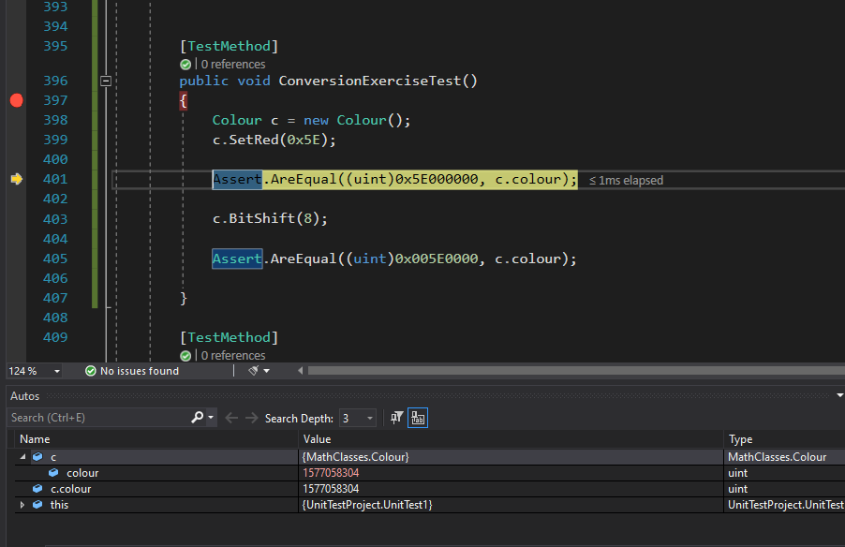

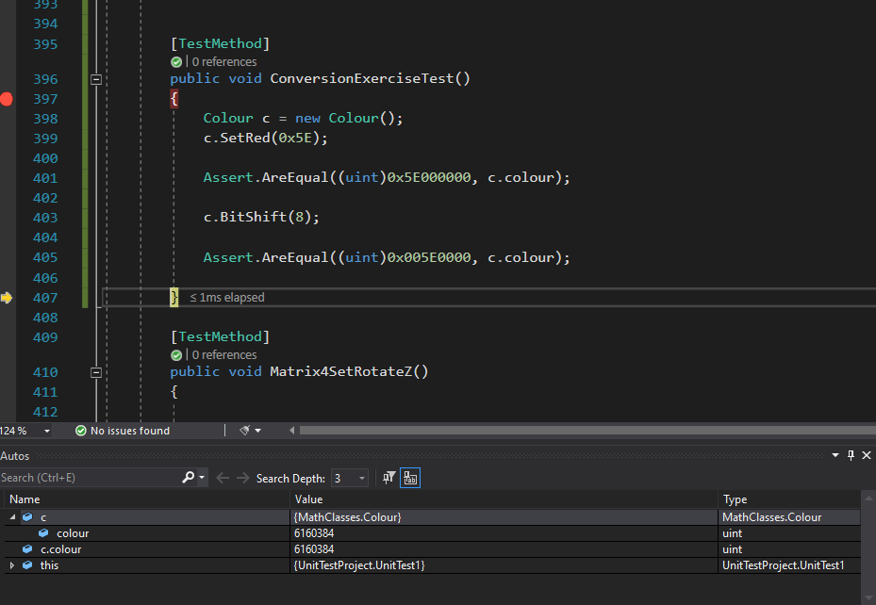

Was correct